Current status and trends of plant protection UAV and its spraying technology in China

Yubin Lan^{1,2,3*}, Shengde Chen¹
(1. National Center for International Collaboration Research on Precision Agricultural Aviation Pesticides Spraying Technology/
College of Engineering, South China Agricultural University, Guangzhou 510642, China;
2. Department of Biological and Agricultural Engineering, Texas A&M University, College Station, Texas, 77843, USA;
3. Texas A&M AgriLife Research and Extension Center, Beaumont, Texas, 77713, USA)

Abstract: As one of the important components of agricultural aviation industry in China, plant protection unmanned aerial vehicles (UAVs) have been developed rapidly in recent years. In order to understand the current development status and limitations of plant protection UAV and its spraying technologies in China, the Department of Agricultural Mechanization Management of the Ministry of Agriculture commissioned South China Agricultural University to perform a survey and generate a report on Analysis of the Development Situation and Policy Suggestion for Agricultural Plant Protection UAV in China in 2016. Based on this report, this paper performed statistical analyses on the development and application of plant protection UAV in China. First, the geographical distribution of operating plant protection UAVs in China was discussed. Second, the current status of spraying technologies for plant protection UAVs were reviewed. Key components in aerial spraying, including the effects of operating parameter of aerial spraying, aerial applied pesticide effect detection, and the promotion and application of aerial spraying technology. Last, future perspectives of spraying technology for plant protection UAV was discussed. This paper may inspire the innovation of precision agricultural aviation technology, the basic theory development of pesticide spraying technology, multi-aircraft cooperative technology and other supporting technologies for UAV-based aerial spraying for scientific research and application by research institutions and enterprises in China.
Keywords: plant protection UAV, aerial spraying, application, spraying technology
DOI: 10.33440/j.ijpaa.20180101.0002

Citation: Lan Y B, Chen S D. Current status and trends of plant protection UAV and its spraying technology in China. Int J Precis Agric Aviat, 2018; 1(1): 1–9.

1 Introduction
Plant disease and pest greatly affect agricultural production and food security in China. With global warming and farmland ecological environment changes, occurrence of plant diseases and pests becomes more frequent year by year^{[1,2]}. In August 2012, disasters such as corn armyworm occurred in Northeast and North China, covering an area of more than 5.3 million ha. In July 2013, the second generation of armyworm burst in Shanxi Province. Ground machinery has poor controlling effects on high-stalk crops like corn, more-than-38-million-ha-area autumn grain crops were harmed. The second armyworm outbreaks had become the largest armyworm outbreak in Shanxi during the past 20 years^{[3]}. It is urgent to establish an efficient crop protection system to prevent such kinds of pest outbreaks^{[4]}.
Unmanned aerial vehicles (UAVs) for plant protection, along with the agricultural aviation industry have been developing rapidly in recent years in China^{[5-6]}. Aerial spraying by UAV is a new plant protection practice in China and is characterized by high efficiency and high utilization rate of pesticide. Compared to conventional aerial spraying technologies, the advantages of aerial spraying by a UAV are discussed as follows. It can effectively solve problems causing by high-stalk crops, manual and ground mechanical operations on paddies and steep, mountainous terrains. It is also an efficient way to monitor and control large-area pest and disease outbreaks, reduce the use of rural labor and pesticide ^{[7-9]}. Furthermore, the plant protection UAV that operates at low altitude and low loading can suspend in the air to achieve high-precision position with GPS. Additionally, the downward airflow generated by rotors helps to increase penetrability of droplets on canopy to improve the pesticide effect^{[10-12]}.
In addition, with further improvement of domestic land transfer rate, large-scale agricultural production has become a trend. A new type of plant protection mode with scaled-up and mechanization is urgently needed ^{[13]}. The Ministry of Agriculture has passed fertilizer and pesticide reduction action plan, referring to a goal for achieving zero growth of fertilizer and pesticide use by 2020. Therefore, the plant protection UAV that has the ability to achieve the effect with ultra-low volume spraying fit the goal well. In recent years, China’s agricultural UAV manufacturing industry has increased dramatically driven by the huge market demand. This, in turn, stimulates the rapid development of plant protection UAV and its application technology. To further understand the status and issues of the development of plant protection UAV and its spraying technologies in China, the Department of Agricultural Mechanization Management of the Ministry of Agriculture commissioned South China Agricultural University to write the report on Analysis of the Development Situation and Policy Suggestion for Agricultural Plant Protection UAV in China in 2016. Based on this report, a statistical analysis was performed on the development and application of plant protection UAVs in China. This analysis’ primary focus was the distribution of ownership and actual operating area of plant protection UAVs in various provinces and regions. The current status of UAV-based spraying technologies was reviewed and summarized. Furthermore, the key development directions of spraying technologies for plant protection UAV in the future were pointed out. It is expected to provide references for scientific research and application of research institutions and enterprises, and promote and encourage the development of plant protection UAV industry in China.
2 Application status of plant protection UAV
2.1 Distribution of ownership and development area of plant protection UAV
According to the report on Analysis of the Development Situation and Policy Suggestion for Agricultural Plant Protection UAV in China in 2016, there were 4,262 plant protection UAVs for actual field operation by the end of June 30, 2016. The majority of these UAVs are electric, multi-rotorcraft with pesticides loadings between 5 and 30 L. These UAVs are operated primarily by planting cooperatives, agricultural service organizations and professional flying defense organizations.
As is shown in Figure 1, there are large differences in terms of the ownerships of plant protection UAVs across the various provinces and cities. This differences were associated with the standardization of local agricultural production, the scale of operation, the level of mechanized development, and the local subsidy policy for purchasing agricultural machines. Henan Province, the largest agricultural production province, has the highest quantity (720 and accounting for 16.89% of the total) of plant protection UAVs. Several other major agricultural provinces such as Hebei, Liaoning, Jiangsu, Anhui, Fujian, Shandong, Hunan and Xinjiang Uygur Autonomous Region all have more than 200 UAVs. Summing their UAVs up and the number reaches 2,406, representing 56.45% of the total. At the same time, Heilongjiang Province, also as a major agricultural production province, only has a relative small number of UAVs (88, accounting for 2.06% of the total) since manually piloted fixed-wing aircrafts were mainly used for agricultural aviation plant protection operation.

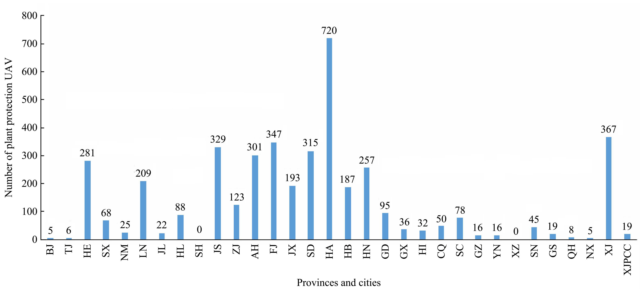
Note: BJ—Beijing, TJ—Tianjin, HE—Hebei, SX—Shanxi, NM—Inner Mongolia, LN—Liaoning, JL—Jilin, HL—Heilongjiang, SH—Shanghai, JS—Jiangsu, ZJ—Zhejiang, AH—Anhui, FJ—Fujian, JX—Jiangxi, SD—Shandong, HA—Henan, HB—Hubei, HN—Hunan, GD—Guangdong, GX—Guangxi, HI—Hainan, CQ—Chongqing, SC—Sichuan, GZ—Guizhou, YN—Yunnan, XZ—Tibet, SN—Shaanxi, GS—Gansu, QH—Qinghai, NX—Ningxia, XJ—Xinjiang, XJPCC—Xinjiang Production and Construction Corps.
Figure 1 Ownership distribution of plant protection UAVs in various provinces in China

Figure 2 shows regional distribution of plant protection UAVs in China in seven major geographic areas: North China, Northeast China, East China, Central China, South China, Southwest China and Northwest China. The highest number of plant protection UAVs are located in Eastern China (Shanghai, Jiangsu, Zhejiang, Anhui, Fujian, Jiangxi and Shandong provinces) and Central China (Henan, Hubei and Hunan provinces) which sums up to 1,608 (37.73%) and 1,164 units respectively. These two geographic areas are followed by Northwest China (Shaanxi, Gansu, Qinghai, Ningxia and Xinjiang), North China (Beijing, Tianjin, Hebei, Shanxi and Inner Mongolia), and Northeast China (Heilongjiang,
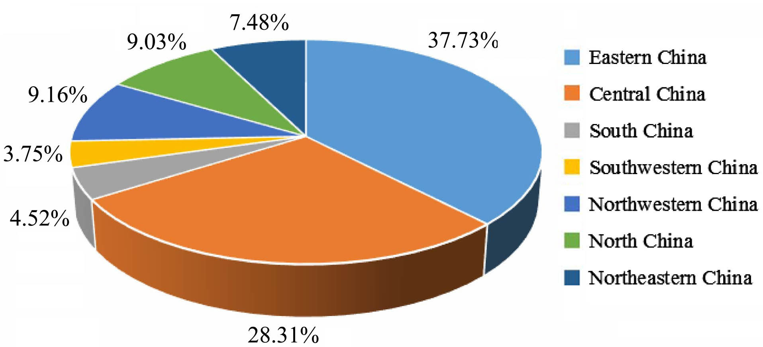
Figure 2 Ownership distribution of plant protection UAVs in various regions in China
Jilin and Liaoning Provinces) with 386 (9.16%), 385 (9.03%) and 319 (7.48%) respectively. South China (Guangdong, Guangxi and Hainan provinces) and the southwestern China (Chongqing, Sichuan, Guizhou, Yunnan and Tibet) possess the fewest UAVs in operation, totaling 163 (4.52%) and 160 (3.75%) respectively.
In Figs.1 and 2, it can be seen that the most advantageous areas for UAV application in China are large agricultural provinces and economically developed areas such as Henan, Shandong, Hunan, Zhejiang, Jiangsu and Xinjiang. Xinjiang province is home to many farm which are suitable for plant protection UAV operations. This is a primary reason that plant protection UAV manufacturers are attracted to set up branches in Xinjiang, in an attempt to further promote aerial spraying operation by plant protection UAV. As an economic-developed area, Guangdong Province has the largest number of agricultural UAV manufacturing enterprises in the country; however, they do not possess the highest number of plant protection UAVs in operation. One explanation for this is the lack of local government subsidies for plant protection UAVs in Guangdong Province. In 2014, the Zhuhai Municipal Government of Guangdong Province allocated special funds to subsidize plant protection UAV up to 30% of retail value. Despite these subsidies, there was little effect on the quantities of plant protection UAV purchases in the province. In contrast, traditionally the areas and provinces with high holdings of plant protection UAV often have subsidies from local governments, thus promoting the local application of plant protection UAV.
2.2 Operation status of plant protection UAV
According to the report on Analysis of the Development Situation and Policy Suggestion for Agricultural Plant Protection UAV in China in 2016, there were 476,035.67 hectares for operational area of plant protection UAV nationwide in 2015. As is shown in Figure 3, Henan Province has the largest operation area of 135,225.3 hectares (28.41% of the total operation area in China), followed by the Xinjiang Uygur Autonomous Region (including Xinjiang Production and Construction Corps) of 76,440.08 hectares (16.06%). Thirdly, Hubei Province (56,540 hectares, 11.46%), Shandong Province (42,192.5 hectares, 8.86%) and Shaanxi Province (32,346 hectares, 6.79%) each had an area of over 30,000 hectares. The operation area of Anhui Province (25,142.8 hectares) and Fujian Province (21,586 hectares) each are roughly 20,000 hectares, and its percentage were 5.28% and 4.53% respectively. Jiangsu Province (18,528.9 hectares, 3.9%), Sichuan Province (13,846.67 hectares, 2.9%), Shanxi Province (13,538.6 hectares, 2.8%) Liaoning Province (10,744.7 hectares, 2.6%) reached over 10,000 hectares individually. All other provinces had less than 10,000 hectares operation area respectively but reached 9865.09 hectares totally in 9 provinces, accounting for 10.47% nationally. Meanwhile, Beijing, Hebei Province, Jilin Province and Qing Provinces, Ningxia Hui Autonomous Region provinces each had an operating area of less than 1,000 hectares collectively, accounting for 0.34% of total in China.

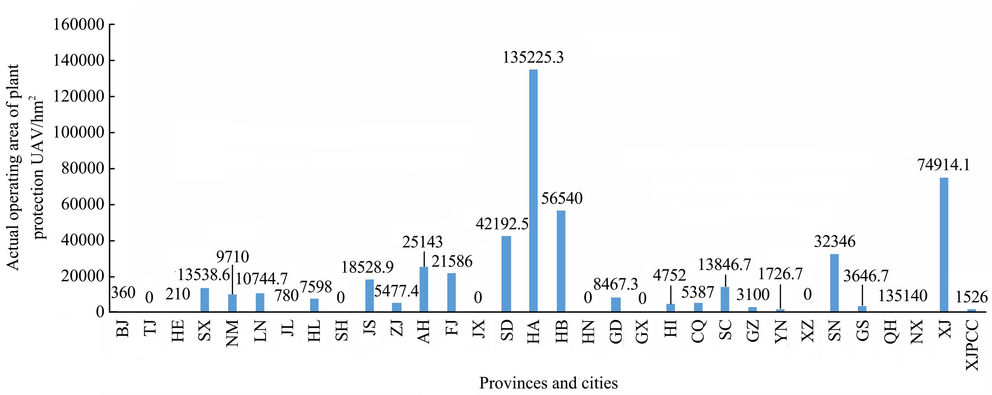
Note: BJ—Beijing, TJ—Tianjin, HE—Hebei, SX—Shanxi, NM—Inner Mongolia, LN—Liaoning, JL—Jilin, HL—Heilongjiang, SH—Shanghai, JS—Jiangsu, ZJ—Zhejiang, AH—Anhui, FJ—Fujian, JX—Jiangxi, SD—Shandong, HA—Henan, HB—Hubei, HN—Hunan, GD—Guangdong, GX—Guangxi, HI—Hainan, CQ—Chongqing, SC—Sichuan, GZ—Guizhou, YN—Yunnan, XZ—Tibet, SN—Shaanxi, GS—Gansu, QH—Qinghai, NX—Ningxia, XJ—Xinjiang, XJPCC—Xinjiang Production and Construction Corps.
Figure 3 Actual operating area distribution of plant protection UAV in various provinces in 2015

Figure 4 shows the regional actual operating area of plant protection UAV in 2015. The plant protection UAV operating area of the Central China (excluding Hunan Province) utilized roughly 191,765.3 hectares, and accounting for 38.28% of the total operating area, making it the largest in China. This was followed by the East China (excluding Jiangxi Province operating area) and the Northwest plan protection UAV operating area, utilizing 112,927.6 hectares (22.62%) and 112,707.8 hectares (22.28%) respectively. Next comes to the southwestern region (excluding the Guangxi operating area) and North China with 24,060.37 hectares (5.05%) and 23,818.63 hectares (5.00%). These UAVs were employed minimally in the northeast and south China with 19,122.7 hectares (4.02%) and 13,219.33 hectares (2.78%) each.
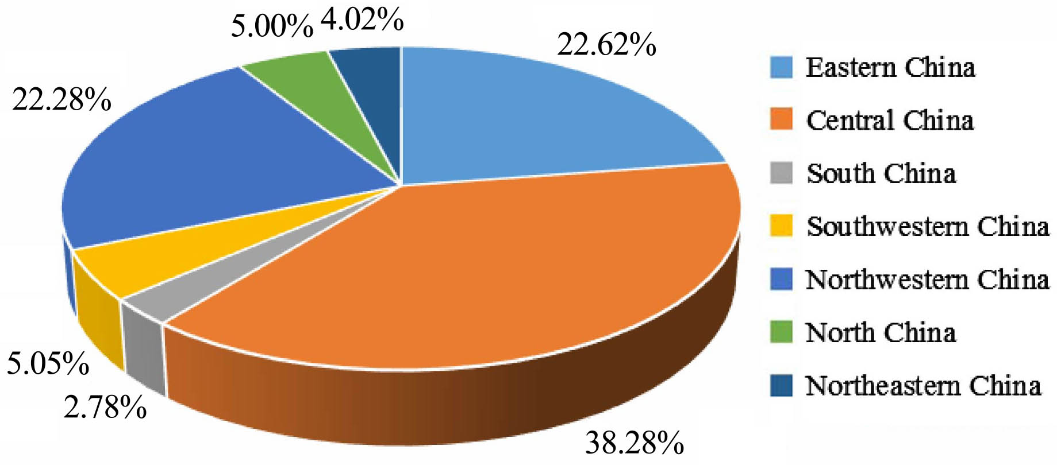
Figure 4 Actual operating area distribution of plant protection UAV in various regions in 2015

It can be seen from Figs. 3 and 4 that operating areas by plant protection UAV are primarily comprised of the large agricultural provinces, such as Henan, Hebei, Shandong and Xinjiang, etc. Among them, Henan Province had the highest subsidies for plant protection UAV with the largest area of application and promotion. In return, the operating area of UAVs in central, eastern and northwest of China which are the main cereal grain production, which are far greater than that of other regions.
3 Research progress of plant protection UAV-based spraying technologies
3.1 Key technologies for aerial spraying
3.1.1 Aerial variable-rate spraying technology
Aerial variable-rate spraying technology is able to increase the precision of plant protection spray applications. With this technology, crops are able to be sprayed for different purposes by synthesizing information about target crops, such as field pest and disease area, crop row spacing and plant density and other application parameters^{[14]}. Compared to traditional high-capacity spray technology, variable-rate spraying technology can reduce the problem of pesticide overuse, reduce droplet drift, and improve the efficiency of pesticide.
Zhu et al.^{[15]} applied pulse width modulation (PWM) technology to develop a precision spraying system for plant protection UAVs. Their results demonstrated that the precision spraying system could be controlled by PWM technology. The nozzle sprayed uniformly along the flying direction of UAV without missing any spray or spraying too much. On the basis of building the PWM variable-rate spraying system for UAV, Wang et al.^{[16]} developed the ground measurement and control unit by LabWindows/CVI. The pressure and flow rate of the spraying system was remotely controlled through a wireless data transmission module. In this way, variable-rate spraying adjustment for plant protection UAV was achieved. In order to solve problems such as the dull spraying control system for plant protection UAV, Wang et al.^{[17]} designed a dynamic spraying control system and method for plant protection UAV, which the flow rate was able to match the operating speed accurately and automatically with multi-sensor fusion technology. The results show that when operating speed was changed from 0.8 to 5.8 m/s, the average deviation between practical flow rate and theoretical flow rate was only 1.9%. In addition, in order to avoid the problems of low utilization rate of pesticides and environmental pollution caused by plant protection UAV spraying, Wang et al.^{[18]} developed a precision spraying control system for UAV based on image recognition, which used algorithm to classify and identify the crop area and non-crop area in aerial image of the field, and controlled the nozzle based on recognized results to achieve precise spray. The application of variable-rate spraying technology for plant protection UAV have provided technical reference for research, and provide reference guides for the development of precision agricultural spraying technologies in the future.
3.1.2 Aerial electrostatic spraying technology
Aerial electrostatic spraying technology is an innovative application of traditional ground electrostatic spraying technology in spraying system of plant protection UAV^{[19,20]}. In the process of aerial spraying, the electrostatic field between nozzle and target crop is established by high voltage static electricity, which made pesticide liquid charge with the same polarity as nozzle after atomizing. According to the principle of electrostatic induction, ground plant canopy will cause opposite charge of droplet. As the same-sex charges inter-repelled and the opposite-sex charges inter-attracted, the charged droplet will make directional movement to the ground and eventually attach to various parts of the target crop plants with the effect of electrostatic field forces and other external forces^{[21-23]}. The electrostatic spraying technology not only make droplet attach on the front of the crop leaves, but also in the middle and lower parts of the plants and the back of leaves, which increase the droplets deposition rate while reducing droplet drift, and improve the ecological environment around the application area.
Ru et al.^{[24]} designed the electrostatic spray system for UAV (XX8D), and the system was tested at different altitudes with electrostatic and non-electrostatic spray in-paddy. The result showed that the electrostatic spray has a significant effect on increasing droplet deposition. This test is the first time for the electrostatic spraying system to be used in spraying operation of plant protection UAV, but application of electrostatic spraying technology in plant protection UAV remains to be further studied. Therefore, Jin et al.^{[25]} designed an aerial electrostatic spray system for single-rotor helicopter (AF-811). Their studies included the effective spraying width and droplet deposition about their system was carried out and showed that the spraying system had several advantages such as droplet deposition increase and drift reduction. Similarly, Cai et al.^{[26]} developed a new type of contact electrostatic spray system based on the F-50 unmanned helicopter flight platform, and the effect of spray deposition on different charging methods was compared. The result showed that the contact charge and the induction charge can improve the droplet deposition and the uniformity of aerial spray, and the uniformity with contact charge is better. Lian et al.^{[27]} designed a set of electrostatic spray system for multi-rotor UAV (YG20-6 plant protection UAV) and tested the spray effect of the system with the best operating parameters. The test result showed that average droplets deposition density in the upper and middle of collecting device were 133.8 drops/cm² and 113.8 drops/cm² respectively, and increased by 13.6% and 32.6% compared with the non-electrostatic spray.
3.1.3 Other key technologies for aerial spraying
With regard to other key technologies for aerial spraying, Huang et al.^{[28]} developed a low-volume spraying system for small UAV, which cooperated with fully autonomous agricultural UAV to spray pesticides for crops in specific areas. The experiments have verified that the system can be applied in crop fields and achieve increased precision crop management. Ru et al.^{[29]} designed a remote control system based on the unmanned helicopter from German VARIO company. By carrying out the theory research on main influence facts of centrifugal atomizing spray effect and the tests for nozzle performance, the optimal operating parameters of centrifugal atomizing nozzle were obtained. Xue et al^{[30]} designed an UAS to accommodate a spray system, which was interfaced with electronic control systems to activate spray releases based on the GPS coordinates and pre-programmed spray locations. This system has route planning and real-time display, and can be configured for autonomous flight following flight plans with automatic control of the spray system. Han et al.^{[31]} designed an agricultural unmanned helicopter with high application accuracy that combined with manual controlled spray and automatic navigated spray. It can collect real-time data on the growth and victimization of crops through the cameras installed below the UAV. By controlling spraying time and flow rate to achieve precision spray, and it can greatly improve the efficiency and accuracy of pesticide application. The P20 four-rotor agricultural UAV (Guangzhou XAIRCRAFT Co.,Ltd) adopted the GNSS RTK technology to achieve centimeter-level accuracy of UAV spraying operation, which provides conditions for precision spraying. These key technologies have provided technical support and quality assurance for aerial spraying of plant protection UAV, and greatly promoted the application and development of plant protection UAV and its spraying technologies.
3.2 Development of key components for aerial spraying
The key component for aerial spraying of plant protection UAV is the most important factor of pesticide efficacy, and its quality is directly related to the efficiency of aerial spraying. Therefore, a great deal of research is focused on application efficiency of aerial spraying and have been carried out by domestic scholars.
To meet the requirements of high concentration and low volume spraying for plant protection UAV, nozzle is one of the most important parts of plant protection UAV for aerial spraying^{[32-34]}. Zhou et al.^{[35]} tested the performance of an electric-driven centrifugal nozzle designed for aerial spraying with a special test-bed. The results showed that rotary speed of spray dish, flow rate of the nozzle and spray height have a large influence on droplet size and spray width, but little on droplet distribution. Moreover, optimal spray parameters of unmanned helicopters have been obtained based on the main goals of high efficiency, satisfactory uniformity and low energy for plant protection UAV^{[35]}. Aimed at aerial electrostatic single-nozzle applied in the light plane, Zhou et al.^{[36]} improved and redesigned the electrostatic electrode, nozzle processing technology, high-voltage wires and electrode connection. The theory and experiment of the nozzle’s atomization charged mechanism and performance were studied. These results showed that the new aerial electrostatic nozzle can fully meet the need of aerial spray and achieve satisfactory effect in the prevention of pests and diseases. To solve some problems in the application of the ultra-low-volume spraying of plant protection UAVs in China, Wen et al.^{[37]} developed a new swirl nozzle based on the mechanism of swirl atomization and the modular approach. The hydrodynamics and the atomization characteristics of the flow field in the nozzle are studied numerically and experimentally. The physical properties of the fluid and the effect of the atomizer geometry on the atomization characteristics are obtained. The present method and results on the spraying mechanism of nozzle provide the important reference for research and developing the ultra-low-volume variable spraying system of plant protection UAV. In terms of other key components for aerial spraying, Chen et al.^{[38]} designed an anti-shake tank for plant protection UAV, which can reduce the inertia of liquid turbulence caused by attitude changes during operating, and to ensure application quality of plant protection UAV in the dynamic operation. In order to achieve real-time monitoring of liquid quantity in pesticide tank, Jiang et al.^{[39]} developed a solution called dual-pressure liquid quantity monitoring system. This system consisted of double pressure sensors for liquid-level monitor, wave filter for liquid level turbulence, and conversion model for liquid level and liquid quantity. The results showed that the process of data output of the system is stable and reliable in different flying attitude, which could avoid the problems such as less spray and low operating efficiency caused by insufficient pesticides in pesticide tank. An air-assisted hydraulic spraying system for the JT-30 plant protection UAV was designed by Xinjiang Jiangtian Aviation Technology Co,.Ltd, which used air flow generated by high-pressure centrifugal fan to make droplets more uniform. In the influence of air flow, the deposition and penetration of droplets in lower part of plant have been improved, and the drift of droplets also reduce effectively. Lan et al.^{[40]} designed a control device of spray bar for multi-rotor plant protection UAV. The device is able to adjust spray width by adjusting the angle of spray bar, as well as lower the height of nozzle to reduce droplet drift and to improve application efficiency of plant protection UAV. In addition, Lan et al.^{[41]} also designed an anti-drift spray device for plant protection UAV, which can reduce the impact of wind field on droplet deposition by increasing the distance between nozzle and the UAV rotor to achieve the goal of precision aerial spraying.
3.3 Operating parameters for aerial spraying
Operating parameters of plant protection UAV primarily consists of flight height and speed have a large impact on droplet deposition distribution, and influence the operation effect and pesticide utilization. Therefore, the factor of operating parameters of aerial spraying is essential for spray quality of plant protection UAV. In order to achieve the optimal spraying effect, the exploration of impact factors on spraying effect and the optimization of operating parameters has become research hot topics with the wide application of plant protection UAV.
In the aspect of the exploration of impact factors on UAV-based spraying effect, Qiu et al.^{[46]} studied the relationship between spray deposition characteristics and flight height, flight velocity of small unmanned helicopter (CD-10, Wuxi Hanhe Aviation Technology Co., Ltd) and the interaction between two factors, and arranged a test by a second factor three level test. A model of the relationship between droplet deposition distribution and the two factors of flight height and velocity was developed which can provide guidance for the actual production application. Chen et al.^{[47]} used a single-rotor, small unmanned helicopter (HY-B-10L, Shenzhen Hi-tech New Agriculture Technologies Co., Ltd) with different flight parameters of 1-3 m in the working height and 2-5 m/s in the flying speed in the 3 trials, and the similar results were obtained. In order to evaluate the effect of the factors and degree of influence on multi-rotor electric UAV-based spraying deposition to increase the level of droplets deposition on target, Qin et al.^{[48]} investigated the spraying parameters by the central combination test and design concept of Box-Behnken based on the single-factor test. The results show that the decreasing effect sequence on droplet deposition levels on target is flight height, flight velocity and nozzles flow rate. In exploring the effect of plant protection UAV-based spraying for fruit trees and its application prospect, Chen et al.^{[49]} studied the influence of spraying parameters of UAV on droplet deposition distribution in citrus canopy by an orthogonal test of three factors. The results showed that the factors that affected droplet deposition were in order of flight velocity, flight height, and nozzle flow rate. On this basis, Zhang et al.^{[50]} also found types of nozzle and the shapes of tree crown have effects on droplet deposition.
Since the amount of liquid spraying by plant protection UAV is equal to the sum of the amount of droplets deposited on target crops, the amount of droplets drift in the air and the amount of droplets lost on the ground, Wang et al.^{[51]} studied the effects of flight mode (forward and backward), flight height and environmental crosswind on the distribution of droplet deposition based on testing method of deposition quality balance. It shows that the factor of environmental crosswind have a significant impact on droplet deposition, and preliminarily presumed that the different rotor airflow produced by two flight modes of flying forward and backward have a significant impact on the droplet deposition. With the gradual attention to the wind field of UAV rotor, Tang et al.^{[52]} measured the movement and deposition of droplets with a high speed particle image velocimetry (PIV) method at different rotating speeds of rotors (1000-3000 r/min) or at different transverse injecting points (20-50 cm away from its nearby rotors) in the downwash flow field of a multi-rotor agricultural UAV, and the effect of different degrees of downwash flow field on the movement and deposition of droplets was studied. In order to reveal the impact mechanism of droplet deposition distribution by the wind field below agricultural UAV rotor in depth, Chen et al.^{[11,53]} measured the wind field below rotor by using a wireless wind speed sensor and analyzed the effect of three-dimensional wind field below single-rotor and multi-rotor UAV rotor on droplet deposition distribution in rice canopy. The experimental and research results mentioned above have revealed the impact mechanism of various factors on droplet deposition of plant protection UAV aerial spraying from different angles and degree, and it also provided theoretical guidance and reference value for practical spraying of plant protection UAV.
In addition, in the aspect of optimization of operating parameters of plant protection UAV, researchers have carried out explorations on different types of UAVs and crops. As listed in Table 1, for UAV operating parameters optimization, various UAV models have been tested under different flight parameter settings to find more suitable flight altitudes and speeds that could achieve optimum spray droplet deposition for UAV spraying on many crops (Table 1 is a summary of optimal operating parameters obtained by spraying test). Zhang et al.^{[54]} tested the temperature change rate between unsprayed and sprayed by thermal infrared imager and WPH642 UAV to reflect the droplets deposit on rice canopy, and the optimal application parameters of UAV were that flight altitude of 2 m and flight velocity of 1.5 m/s. Qin et al.^{[55]} explored the effect of spray droplet deposition from applications using a UAV (N-3, Nanjing Research Institute for Agricultural Mechanization Ministry of Agriculture) on late season maize at different application heights and effective spraying swath width and showed that 7 meters in the working height and 7 meters in the spraying swath should be chosen as reference of spraying pesticides. Moreover, Qin et al. ^{[48]} also investigated the spraying parameters of multi-rotor UAV by the central combination test and design concept of Box-Behnken based on the single-factor test, and the optimal combination of spraying parameters (flight height of 2.0 m, flight velocity of 3.7 m/s and nozzle flow rate of 430 mL/min) was obtained from the established model. Chen et al.^{[49]} achieved the optimal spraying parameters of six-rotor plant protection UAV by an orthogonal test of three factors for orange tree according to the results of droplet deposition. Similarly, Zhang et al.^{[50]} have done a spraying test for orange trees through the use of four-rotor plant protection UAV, and found that the droplet density on the tree canopy reach a maximum when flight altitude of UAV was 1 m. The experimental results mentioned above have provided a data support and guidance for aerial spraying of plant protection UAV to reduce liquid drift and improve the utilization rate of pesticide to a greater extent.

Table 1 Optimal operating parameters of different types of UAVs
UAV type | Crop | Flight altitudes tested/ m | Optimal flight altitude/ m | Flight speed tested/m·s⁻¹ | Optimal flight altitude/m·s⁻¹
WPH642 Helicopter | Rice | 1,2,3,4 | 2 | 1.5,2.0,2.5 | 1.5
HY-B-10L Helicopter | Rice | 1,2,3 | 2 | 2~5 | 2~3
N-3 Helicopter | Maize | 5,7,9 | 7 | 3 | N/A
P-20 Quad-rotor UAV | Rice | 1~3 | 2 | 2~6 | 3.7
TXA-16 Six-rotor UAV | Citrus | 2,4,6 | 4 | 1.5,2.0,2.5 | 2.5
3W-LWS-Q60S Quad-rotor UAV | Citrus | 0.5,1,1.5 | 1 | 1 | N/A

3.4 Test of aerial spraying efficacy
In the process of aerial spraying of plant protection UAV, the complexity of the operating environment and the variability of operating parameters leading to droplet deposition and droplet movement are difficult to predict. Therefore, the deposition effect and distribution characteristics of pesticide has become an important reference for guiding the aerial spraying operation. In order to detect the distribution of droplet deposition quickly and better understand the distribution characteristics of droplet deposition of aerial spraying, the study of aerial spraying efficacy has become an important part of plant protection UAV aerial spraying technologies.
To verify and evaluate the artificial path planning and the actual operating effect in visual remote flight mode, Peng et al.^{[56]} designed a wireless transmission system based on GPS and implemented straight flight experiment and the real-time path planning flight experiment on the base of the paddy field boundary which determined by visual and experience. The results showed that the artificial planning route deviated from the ideal flight path significantly for the reason of no reference, and the skip rate was 17.1%, duplication operation occupied 8.2%, and outside wasted region accounted for 0.7%. Wang et al.^{[57]} proposed a novel measurement method of spatial pesticide spraying deposition quality balance for UAV, which were made for collecting the droplets of UAV pesticide application in 4 directions (top, bottom, upwind and downwind) to analyze the spatial droplet deposition distribution. The method can provide valuable information for the research of UAV pesticide application techniques and the establishment of the standard of spray deposition and drift tests of UAV in crop field. In addition, in order to realize the rapid acquisition of the effect of droplet deposition spraying by plant protection UAV, Zhu et al.^{[117]} developed a custom software package entitled “DepositScan” for evaluating the droplet deposition distribution, which allowing for determination of individual droplet sizes, overall distributions, total droplet number, droplet density, spray deposit volume and percent coverage from the exposed card. Zhang et al.^{[54]} tested the temperature change rate between unsprayed and sprayed by thermal infrared imager and WPH642 UAV to reflect the droplets deposit on rice canopy, and showed that the thermal infrared imager could reflect the droplets deposit law exactly. Zheng et al.^{[58]} established a detection method that uses the reflective wave of laser radars. Positional information for applied droplets was recognized and extracted and the coordinate was transformed, and the sample time that could describe the droplets distribution was analyzed and determined. In addition, the dynamic proportion was used to eliminate the drift droplets and the effective distribution range was determined. Zhang et al.^{[59]} developed a sensor with a variable dielectric capacitor and network system to measure deposition volume in near real-time. The results of testing showed that compared to water sensitive paper image analysis, the degree of fit for the distribution curve is 0.9146 with relative measurement errors of 10%-50%. Similarly, Cai et al^{[60]} designed a sensor for real-time detection of the effect of droplet deposition in aerial spraying application based on the principle of common-plane plug-in capacitor, with measurement accuracy of 0.1 μg/cm and single point measurement speed of 10 μs. The sensor is able to measure the amount of droplet deposition and observe the process of droplet evaporation. Compared with traditional ground detection techniques, these studies have shortened the cycle of actual tests and simplified actual test process. This which is helpful in accelerating application and popularization of aerial spraying technology, improving its effect.
3.5 Promotion and application of plant protection UAV-based spraying technology
In order to accelerate the research and popularization of plant protection UAV-based aerial spraying technologies, many experimental demonstrations and technical promotions for different crops were carried out by national research institutes and enterprise units related to UAV, such as South China Agricultural University, Nanjing Research Institute for Agricultural Mechanization, China Agricultural University, DJI Technology Co., Ltd, X-aircraft Co., Ltd, et al. Since the national key research and development plan of high efficiency ground and aerial spraying technology and intelligent equipment was set up in 2016, the precision agricultural aviation team from South China Agricultural University has carried out more than 40 research projects in various crops such as orange trees, rice, cotton and wheat in Yunnan, Hunan, Xinjiang, Henan and other provinces. This has played a significant role in promoting and leading the development of plant protection UAV-based aerial spraying technologies. Further supporting and enhancing the effectiveness of plant protection UAV-based aerial spraying technologies, the National Aviation Plant Protection Science and Technology Innovation Alliance was established in 2016 by Anyang Quanfeng Aviation Plant Protection Technology Co., LTD and South China Agricultural University. The Alliance organized more than 60 groups concerned with agricultural UAVs and has become an important landmark for the application and development of UAV-based aerial spraying technologies in China. The alliance has organized a number of enterprises to carry out wheat aphid control and cotton defoliant spraying tests in 2016 and 2017. In August 2016, over 20,000 hectares were impacted by the outbreak of mythimnaseparata walker disease in Shaanxi Province. The alliance organized a number of member units and mobilized hundreds of UAV for emergency prevention and relief work. This was the first cooperation for UAV-based aerial spraying in China which established an operational model for the use of UAV for large-scale pest control moving forward.

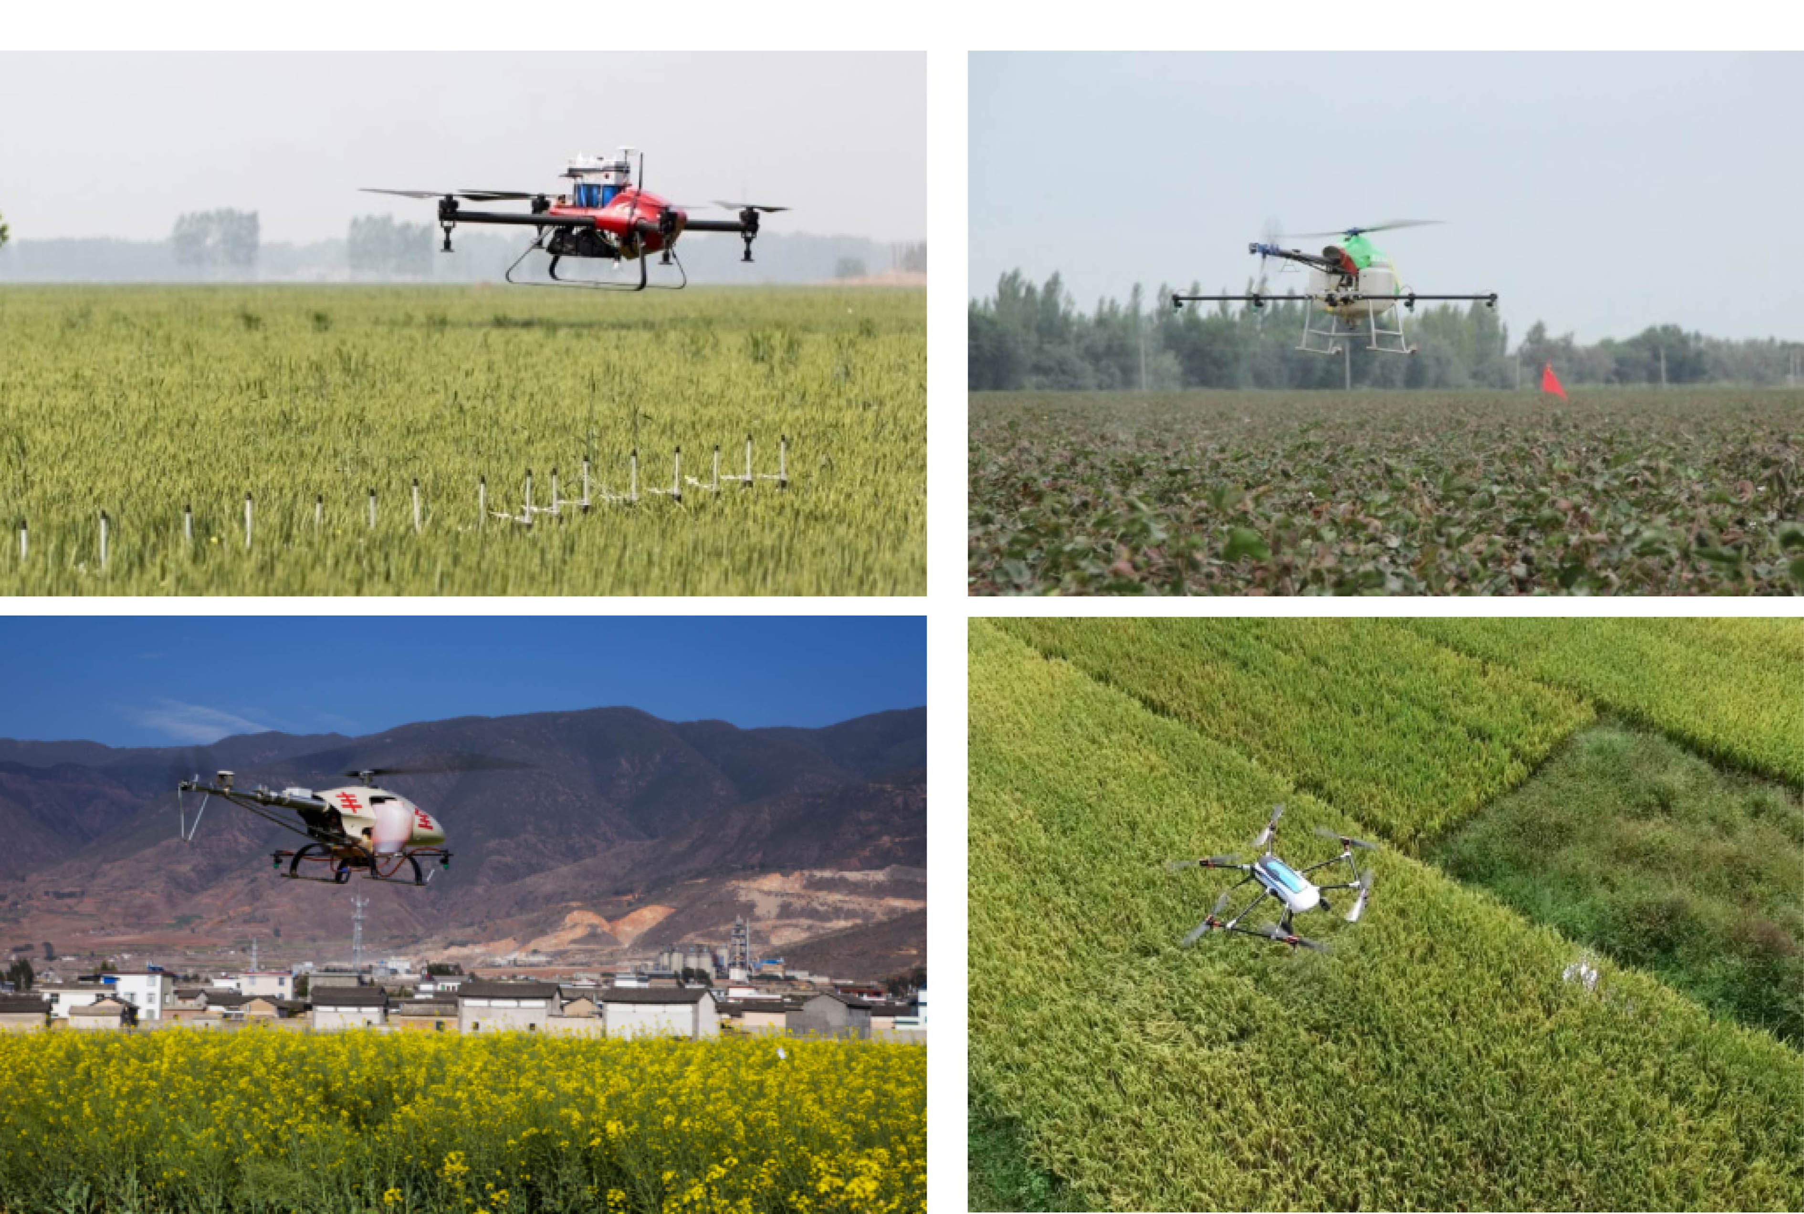
Figure 5 Plant protection UAVs spraying for different crops

4 Analysis of development trend of plant protection UAV-based spraying technologies
4.1 Precision aerial spraying technology
The basic requirement of plant protection and pesticide application is to have good efficacy. Meanwhile, increasing the effective utilization but reducing the use of pesticides are also the inevitable requirements for the future development of plant protection technologies. Precision aerial spraying technology serves as an effective means to achieve this goal through the use of various technologies and information tools. These tools and technology allow UAV technologies to achieve maximum productivity of agricultural aviation operations. There are a number of technologies that assist aerial applicators including global positioning systems (GPS) and geographic information systems (GIS), remote sensing system (RS), and variable-rate (VR) controllers, as exhibited in Figures 1. Remote sensing systems provide precise images for spatial analyses of plant stress due to water or nutrient status in the field, disease, and pest infestations. Through image processing and GIS, remote sensing data are converted into prescription maps for variable-rate aerial application^{[61,62]}.
Nowadays, some aerial spraying has achieved variable-rate
spraying to a certain degree, which can adjust the flow of spraying system based on the flight parameters of UAV and keeping the dosage of every area basically unchanged. But it is not the real precise spraying for plant protection UAV. Precision spraying needs to spray variably according to the extent of crop diseases and insect pests. In the future, we need to strengthen the research of image processing, variable-rate spraying, data fusion and other technologies, and apply these technologies to aerial spraying of plant protection UAV to achieve its precise spraying.
4.2 Basic theory of spraying technology
In the process of pesticides spraying, the droplets spraying by plant protection UAV are smaller than other plant protection machinery and are susceptible to influence factors such as wind field generated by rotor and environmental air-flow. It will lead to some problems such as instability of droplet deposition region, unclear of droplet motion law and ease of droplet drift etc. It is worth noting that droplet deposition and drift is an important factor in deciding the efficiency of pesticide application. At present, the domestic research on the law of droplet deposition and drift for various types of plant protection UAVs is still not thorough. Due to of the diversity of plant protection UAVs and the variety of crops in China, further research not only need to study the droplet deposition law of aerial spraying under different weather conditions (temperature, humidity and atmospheric) and operating parameters, but also need to establish an accurate simulation model of droplet deposition distribution. This model can select optimal operating parameters and droplet size for different types of plant protection UAV by analyzing the droplet deposition law before field tests to achieve the best pesticide spray effect.
4.3 Multi-UAV cooperative technology
With the extensive implementation of precision aerial spraying, information detection and pesticide spraying of UAV have different requirements, and single UAV is difficult to effectively accomplish various tasks at the same time. In order to make up for the shortcomings of single-UAV operations, researchers have begun to research multi-UAV cooperative technology. Multi-UAV cooperative operation is based on single-UAV operation, to achieve intelligent networking of multi UAVs. Each single UAV is required to be able to coordinate the task for the whole so as to effectively cover a large area and conduct information interaction and collaboration. With technological advances in Internet of Things (IoT) and big data, multi-UAV cooperative operation will be a greater extent to save labor costs and improve the efficiency of precision aerial operations.
4.4 Supporting technologies for plant protection UAV-based aerial spraying
In recent years, plant protection UAV-based aerial spraying operation has become one of the most important components of agricultural aviation applications as its large-scale application. As UAV-based aerial spraying application with high-degree atomization of spray liquid, droplets have easy to drift and other characteristics. In order to ensure the effective application of UAV-based aerial spraying, supporting technologies for UAV-based aerial spraying have a huge research potential, such as R&D technologies for nozzle, chemical agent and adjuvant, etc. In which, these nozzles may include the electrostatic nozzle, the adjustable spray nozzle for droplet size and spray flow and others. These chemical agent for aerial spraying by UAV may include the ultra-low-volume liquid, the nano-biological agent and others. These chemical adjuvant for aerial spraying by UAV may include the modified vegetable-oil adjuvant, the organosilicone adjuvant and others. The development and application of these technologies will provide a strong guarantee for precision agricultural aviation application by effectively reducing drift and loss of droplets and promoting the absorption of the active ingredients in crop.
5 Conclusions
Accelerating the popularization and application of plant protection UAV is of urgent need in the construction of modern agriculture in China. Nowadays, practices have proven that plant protection UAV and its spraying technologies have made great progress and application in China due to their irreplaceable advantages in terms of non-limitation on crop growth and topographical conditions, operational efficiency improvement, cost efficiency and so on. With the development of economy, China faces the severe situation of insufficient rural labor brought by population aging and urbanization. In order to ensure the stable and sustainable development of agriculture in China, and accelerate the process of agricultural mechanization and modernization, plant protection UAV which replaced traditional manpower sprayer meet the requirements of the current development of agricultural modernization. And its low-altitude and low-volume spraying technologies have greatly promoted the level of plant protection mechanization in China.
In addition, from the perspective of the development history of UAV in Japan, other developed countries and the domestic market demand, plant protection UAV is thriving. These technologies have broad market prospects and ever-expanding potential applications. In order to ensure the healthy development and application of plant protection UAV, the urgency of the in-depth study of plant protection UAV and its low-altitude and low-volume spraying technologies couldn’t be ignored. Meanwhile, a better understanding of plant protection UAV-based spraying technologies will help to design and optimize plant protection UAV and its spray components, and so as to promote the efficient use of pesticides, provides great significance to the healthily and orderly development of the plant protection UAV market in China.

Acknowledgments
We acknowledge that this work was financially supported by the National Key Technologies Research and Development Program (2016YFD0200700), Guangdong Leading Talent Project (2016LJ06G689), 111 Project (D18019), Educational Commission of Guangdong Province of China for Platform Construction (2015KGJHZ007), and Science and Technology Planning Project of Guangdong (2017B010117010).

[References]
- Zhang J C, Yuan L, Wang J H, Luo J H, Du S H, Huang W J. Research progress of crop diseases and pests monitoring based on remote sensing. Transactions of the CSAE, 2012, 28(20): 1–11. (in Chinese)
- Zhao Q Z, Jin G C, Zhou W J, Wang C J, Dai J G. Information collection system for diseases and pests in cotton field based on mobile GIS. Transactions of the CSAE, 2015, 31(4): 183–190. (in Chinese)
- Yi X K. Discussion on the present situation and development trends of plant protection equipment in China. Journal of Agricultural Mechanization Research, 2007, (3): 218–220. (in Chinese)
- Qi F, Zhu M, Zhou X Q, Wei X M. Relationship analysis between agricultural engineering and agricultural modernization in China. Transactions of the CSAE, 2015, 31(1): 1–10. (in Chinese)
- Zhou Z Y, Zang Y, Luo X W, Lan Y B, Xue X Y. Technology innovation development strategy on agricultural aviation industry for plant protection in China. Transactions of the CSAE, 2013, 29(24): 1–10. (in Chinese)
- Zhou Z Y, Ming R, Zang Y, He X G, Luo X W, Lan Y B. Development status and countermeasures of agricultural aviation in China. Transactions of the CSAE, 2017, 33(20): 1–13. (in Chinese)
- Zhang D Y, Lan Y B, Chen L P, Wang X, Liang D. Current status and future trends of agricultural aerial spraying technology in China. Transactions of the CSAM, 2014, 45(10): 53–59. (in Chinese)
- Zhou Z Y, Yuan W, Chen S D. Current status and future directions of rice plant protection machinery in China. Guangdong Agricultural Sciences, 2014, (5): 178–183. (in Chinese)
- Chen S D, Lan Y B, Li J Y, Xu X J, Wang Z G, Peng B. Evaluation and test of the effective spraying width of aerial spraying on plant protection UAV. Transactions of the CSAE, 2017, 33(7): 82–90. (in Chinese)
- Xue X Y, Tu K, Qin W C, Lan Y B, Zhang H H. Drift and deposition of ultra-low altitude and low volume application in paddy field. Int J Agric & Biol Eng, 2014, 7(4): 23–28.
- Chen S D, Lan Y B, Bradley K F, Li J Y, Liu A M, Mao Y D. Effect of wind field below rotor on distribution of aerial spraying droplet deposition by using multi-rotor UAV. Transactions of the CSAM, 2017, 48(8): 105–113. (in Chinese)
- Chen S D, Lan Y B, Li J Y, Zhou Z Y, Liu A M, Xu X J. Comparison of the pesticide effects of aerial and artificial spray applications for rice. Journal of South China Agricultural University, 2017, 38(4): 103–109. (in Chinese)
- Luo X W, Liao J, Hu L, Zang Y, Zhou Z Y. Improving agricultural mechanization level to promote agricultural sustainable development. Transactions of the CSAE, 2016, 32(1): 1–11. (in Chinese)
- Qiu B J, Yan R, Ma J, Guan X, Ou M. Research progress analysis of variable rate sprayer technology. Transactions of the CSAM, 2015, 46(3): 59–72. (in Chinese)
- Zhu H, Lan Y B, Wu W F, Hoffmann W C, Huang Y, Xue X Y, et al. Development of a PWM precision spraying controller for unmanned aerial vehicles. Journal of Bionic Engineering, 2010, 7(3): 276–283.
- Wang L, Lan Y B, Hoffmann W C, Bradley K F, Chen D, Wang S M. Design of variable spraying system and influencing factors on droplets deposition of small UAV. Transactions of the CSAM, 2016, 47(1): 15–22. (in Chinese)
- Wang D S, Zhang J X, Li W, Xiong B, Zhang S L, Zhang W Q. Design and test of dynamic variable spraying system of plant protection UAV. Transactions of the CSAM, 2017, 48(5): 86–93. (in Chinese)
- Wang L H, Gan H M, Yue X J, Lan Y B, Wang J, Liu Y X, et al. Design of a precision spraying control system with unmanned aerial vehicle based on image recognition. Journal of South China Agricultural University, 2016, 37(6): 23–30. (in Chinese)
- Zhang Yali, Lan Yubin, Bradley K F, Xue X Y. Development of aerial electrostatic spraying systems in the United States and applications in China. Transactions of the CSAE, 2016, 32(10): 1–7. (in Chinese)
- Liu W L, Zhou Z Y, Chen S D. Status of aerial electrostatic spraying technology and its application in plant protection UAV. Journal of Agricultural Mechanization Research, 2018, (5): 1–9. (in Chinese)
- Luo T Q, Wang Z, Yang S T, Gao L R. Numerical model of electrostatic field in electrostatic charged spray. Transactions of the CSAE, 1994, 10(4): 91–95. (in Chinese)
- Zhu H P, Xian F S, Gao L R. Summary of research on electrostatic spraying technique theory and its application. Transactions of the CSAM, 1989, (2): 53–59. (in Chinese)
- Shen C J, Jia S X, Tang Z H, Zhou Y, Meng X J, Yuan L Q. Research actuality and application prospects of esticide electrostatic spraying. Journal of Agricultural Mechanization Research, 2010, 32(4): 10–13. (in Chinese)
- Ru Y, Jin L, Jia Z C, Bao R, Qian X D. Design and experiment on electrostatic spraying system for unmanned aerial vehicle. Transactions of the CSAE, 2015, 31(8): 42–47. (in Chinese)
- Jin L, Ru Y. Research on UAV-based aerial electrostatic spraying system. Journal of Agricultural Mechanization Research, 2016, (3): 227–230. (in Chinese)
- Cai Y L. Design and test of contact electrostatic spray system for low-altitude UAV. Zhenjiang: Jiangsu University, 2017. (in Chinese)
- Lian Q. Experimental research on electrostatic spray system for multi-rotor UAV. Daqing: Heilongjiang Bayi Agricultural University, 2016. (in Chinese)
- Huang Y B, Hoffmann W C, Lan Y B, Wu W, Bradley K F. Development of a spray system an unmanned aerial vehicle platform. Applied Engineering in Agriculture, 2009, 25(6): 803–809.
- Ru Y, Jia Z C, Fan Q N, Che J. Remote Control Spraying System Based on Unmanned Helicopter. Transactions of the CSAM, 2012, 43(6): 47–52. (in Chinese)
- Xue X Y, Lan Y B, Sun Z, Chang C, Hoffmann W C. Development an unmanned aerial vehicle based automatic aerial spraying system. Computers and electronics in agriculture, 2016, 128: 58–66.
- Han J D, Qi J T. A unmanned helicopter for spraying. Chinese patent: CN104908946B, 2017-04-12.
- Ru Y, Jin L, Zhou H P, Jia Z C. Performance experiment of rotary hydraulic atomizing nozzle for aerial spraying application. Transactions of the CSAE, 2014, 30(3): 50–55. (in Chinese)
- Wang X N, He X K, Song J L, Herbst A. Effect of adjuvant types and concentration on spray drift potential of different nozzles. Transactions of the CSAE, 2015, 31(22): 49–55. (in Chinese)
- Zhou Q Q, Xue X Y, Qian S Y, Qin W C. Application status and research direction of nozzles in aviation spray. Journal of Chinese Agricultural Mechanization, 2016, 37(10): 234–237. (in Chinese)
- Zhou L X, Xue X Y, Sun Z, Zhang S C, Kong W, Zhang T, et al. Experimental study on electrical-driven centrifugal nozzle of aerial sprays. Journal of Chinese Agricultural Mechanization, 2011, (1): 107–111. (in Chinese)
- Zhou H p, Ru Y, Shu C R, Jia Z C. Improvement and experiment of aerial electrostatic spray device. Transactions of the CSAE, 2012, 28(12): 7–12. (in Chinese)
- Wen S, Lan Y B, Zhang J T, Li S H, Zhang H Y, Xing H. Analysis and experiment on atomization characteristics of ultra-low-volume swirl nozzle for agricultural unmanned aviation vehicle. Transactions of the CSAE, 2016, 32(20): 85–93. (in Chinese)
- Chen B. A tank with anti-dashing function for plant protection UAV. Chinese patent：CN302856274S, 2014-06-25.
- Jiang R, Zhou Z Y, Xu Y, Lan Y B, Luo X W. Design and experiment of liquid quantity monitor for pesticide tank in spraying UAV. Transactions of the CSAE, 2017, 33(12): 107–115. (in Chinese)
- Lan Y B, Chen S D, Zhang H Y. A boom control device for multi-rotor UAVs. Chinese patent: ZL201620908572.4, 2017-03-22.
- Lan Y B, Chen S D, Yao W X. A drift reduce device for plant protection UAVs. Chinese patent: ZL201620291981.4, 2018-01-06.
- Liao J, Zang Y, Zhou Z Y, Luo X W. Quality evaluation method and optimization of operating parameters in crop aerial spraying technology. Transactions of the CSAE, 2015, 31(S2): 38–46. (in Chinese)
- Qin W C, Xue X Y, Cui L F, Zhou Q Q, Xu Z F, Chang F L. Optimization and test for spraying parameters of cotton defoliant sprayer. Int J Agric & Biol Eng, 2016, 9(4): 63–72.
- Wang X N, He X K, Wang C L, Wang Z C, Li L L, Wang S L, et al. Spray drift characteristics of fuel powered single-rotor UAV for plant protection. Transactions of the CSAE, 2017, 33(1): 117–123. (in Chinese)
- Qin W C, Qiu B J, Xue X Y, Chen C, Xu Z F, Zhou Q Q. Droplet deposition and control effect of insecticides sprayed with an unmanned aerial vehicle against plant hoppers. Crop Protection, 2016, 85:79–88.
- Qiu B J, Wang L W, Cai D L, Wu J H, Ding G R, . Effects of flight altitude and speed of unmanned helicopter on spray deposition uniform. Transactions of the CSAE, 2013, 29(24): 25–32. (in Chinese)
- Chen S D, Lan Y B, Li J Y, Zhou Z Y, Jin J, Liu A M. Effect of spray parameters of small unmanned helicopter on distribution regularity of droplet deposition in hybrid rice canopy. Transactions of the CSAE, 2016, 32(17): 40–46. (in Chinese)
- Qin W C, Xue X Y, Zhang S C, Gu W, Chen C. Optimization and test of spraying parameters for P20 multi-rotor electric unmanned aerial vehicle based on response surface method. Journal of Jiangsu University(Natural Science Edition), 2016, 37(5): 548–555．(in Chinese)
- Chen S D, Lan Y B, Zhou Z Y, Liao J, Zhu Q Y. Effects of spraying parameters of small plant protection UAV on droplets deposition distribution of orange trees. Journal of South China Agricultural University, 2017, 38(5): 97–102. (in Chinese)
- Zhang P, Lv Q, Yi S L, Liu Y, He S L, Xie R J, et al. Evaluation of spraying effect using small unmanned aerial vehicle(UAV) in citrus orchard. Journal of Fruit Science, 2016, 33(1): 34–42. (in Chinese)
- Wang C L, He X K, Wang X N, Wang Z C, Wang S L, Li L L, et al. Distribution characteristics of pesticide application droplets deposition of unmanned aerial vehicle based on testing method of spatial quality balance. Transactions of the CSAE, 2016, 32(24): 89–97. (in Chinese)
- Tang Q, Zhang R R, Chen L P, Xu M, Yi T C, Zhang B. Droplets movement and deposition of an eight-rotor agricultural UAV in downwash flow field. Int J Agric & Biol Eng, 2017, 10(3): 47–56.
- Chen S D, Lan Y B, Li J Y, Zhou Z Y, Liu A M, Mao Y D. Effect of wind field below rotor of unmanned helicopter on droplet deposition distribution of aerial spraying. Int J Agric & Biol Eng, 2017, 10(3): 67–77.
- Zhang J, He X K, Song J L, Zeng A J, Liu Y J, Li X F. Influence of spraying parameters of unmanned aircraft on droplets deposition. Transactions of the CSAM, 2012, 43(12): 94–96. (in Chinese)
- Qin W C, Xue X Y, Zhou L X, Zhang S C, Sun Z, Kong W, et al. Effects of spraying parameters of unmanned aerial vehicle on droplets deposition distribution of maize canopies. Transactions of the CSAE, 2014, 30(5): 50–56. (in Chinese)
- Peng X D, Zhang T M, Li J Y, Qi H X, Liao Y H, Zhuang X L. Experiment of straight and airline flight operation for farmland based on UAV in visual remote mode. Transactions of the CSAM, 2014, 45(11): 258–263. (in Chinese)
- Wang C L, He X K, Wang X N, Jane B, Herbst A, Wang Z G, et al. Testing method of spatial pesticide spraying deposition quality balance for unmanned aerial vehicle. Transactions of the CSAE, 2016, 32(11): 54–61. (in Chinese)
- Zheng Y J, Yang S H, Lan Y B, Hoffmann W C, Zhao C J, Chen L P, et al. A novel detection method of spray droplet distribution based on LIDARs. Int J Agric & Biol Eng, 2017, 10(4): 54–65.
- Zhang R R, Chen L P, Lan Y B, Xu G, Kan J, Zhang D Y. Development of a deposit sensing system for aerial spraying application. Transactions of the CSAM, 2014, 45(8): 123–127. (in Chinese)
- Cai K, Lan Y B, Li J Y. A device for detecting droplet deposition and evaporation of pesticides. Chinese patent: CN206020220U, 2017-03-15.
- Lan Y B, Thomson S J, Huang Y B, Hoffmann W C, Zhang H H. Current status and future directions of precision aerial application for site-specific crop management in the USA. Computers & Electronics in Agriculture, 2010, 74(1): 34–38.
- Lan Y B, Chen S D, Bradley K F. Current status and future trends of precision agricultural aviation technologies. Int J Agric & Biol Eng, 2017, 10(3): 1–17.

Received date: 2018-02-22 Accepted date: 2018-05-28 Biographies: Shengde Chen, PhD, research interest: precision agriculture aviation technology and equipment, Email: 1163145190@qq.com. *Corresponding author: Yubin Lan, PhD, Professor, research interest: precision agricultural aviation application. College of Engineering, South China Agricultural University, Guangzhou 510642, China. Tel: +86-20-85280783, Email: ylan@scau.edu.cn.

